**Task on Ec2**

**1) Launch one ec2 using Amazon Linux 2 image and add script in user data to install Apache.**

• **Log in to AWS Management Console**:

* Navigate to the [EC2 Dashboard](https://console.aws.amazon.com/ec2/).

• **Launch a New Instance**:

* Click on **Launch Instance**.

• **Choose Amazon Linux 2 AMI**:

* Select **Amazon Linux 2 AMI (HVM), SSD Volume Type**.

• **Select Instance Type**:

* Choose **t2.micro** (eligible for the free tier).

• **Configure Instance Details**:

* In the **Configure Instance** section, scroll down to **Advanced Details**.

• **Add User Data Script**:

* In the **User data** field, paste the following script:

bash

CopyEdit

#!/bin/bash

yum update -y

yum install -y httpd

systemctl start httpd

systemctl enable httpd

echo <h1>Hello apache httpd installed successfully<h1> > /var/www/html/index.html

* This script updates the system, installs Apache, starts the service, enables it to start on boot, and creates a test HTML page.

• **Add Storage (Optional)**:

* Adjust storage settings if necessary.[Sysdig+4AWS in Plain English+4Medium+4](https://aws.plainenglish.io/how-to-launch-an-ec2-instance-in-aws-15db3b22101d?utm_source=chatgpt.com)

• **Configure Security Group**:

* Create a new security group or select an existing one.
* Ensure it allows inbound traffic on **port 22 (SSH)** and **port 80 (HTTP)**.

• **Review and Launch**:

* Review your settings and click **Launch**.
* Select an existing key pair (proxy.pem) or create a new one to access the instance via SSH.

• **Obtain Public IP Address**:

* After the instance is running, note the **Public IPv4 address** from the EC2 Dashboard.

• **Access the Web Server**:

* Open a web browser and enter the instance's public IP address.

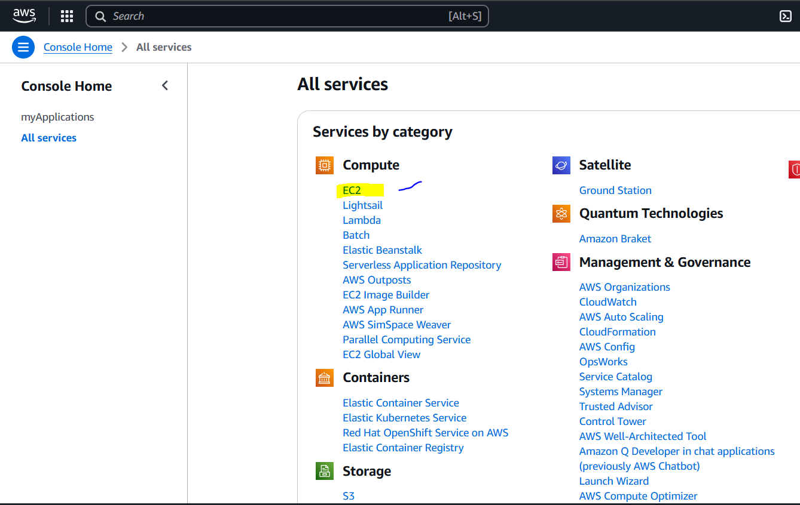

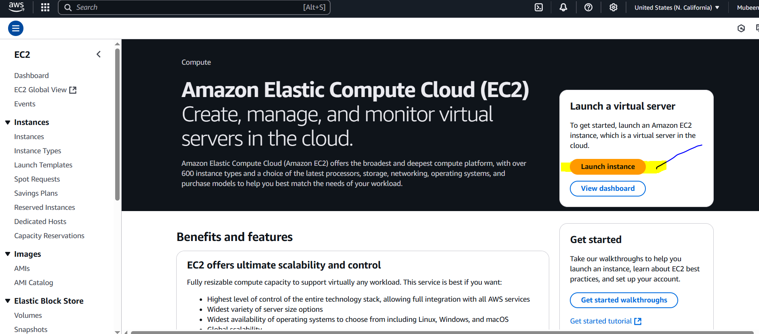

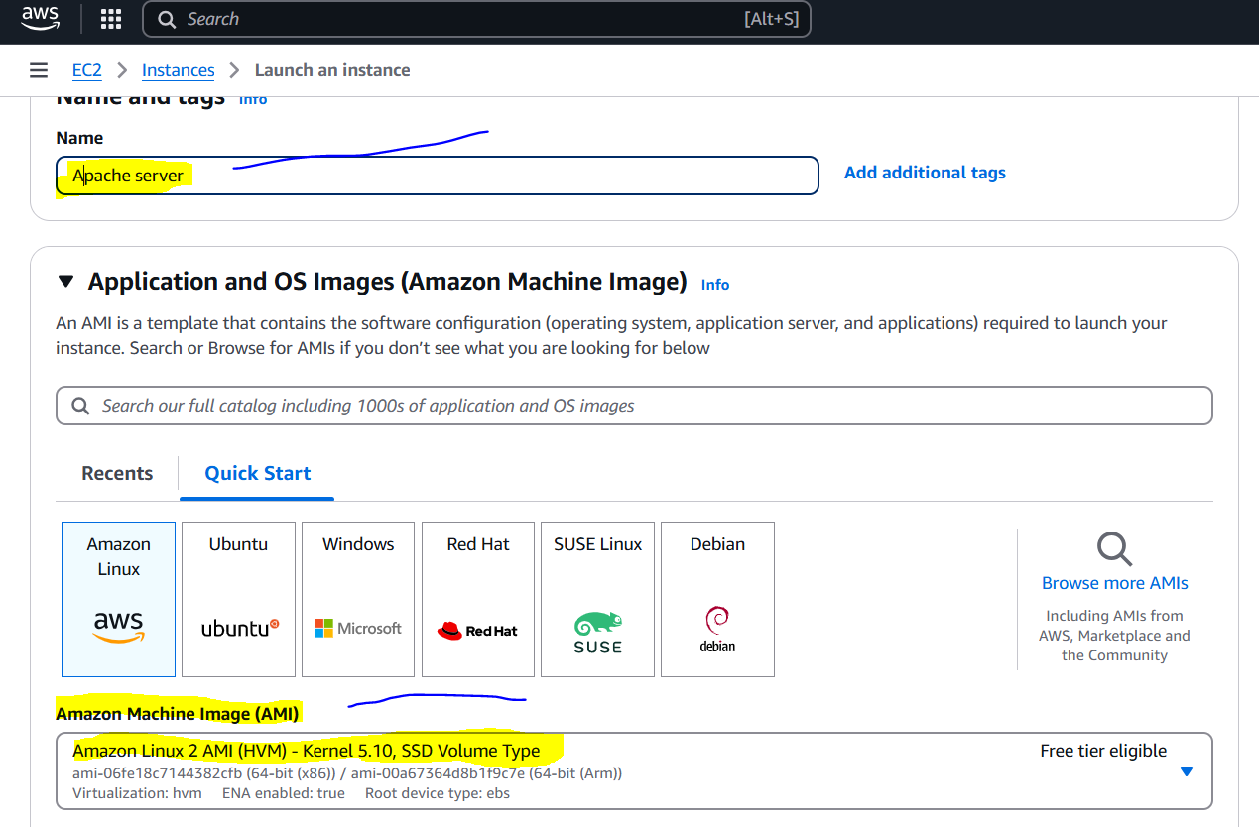

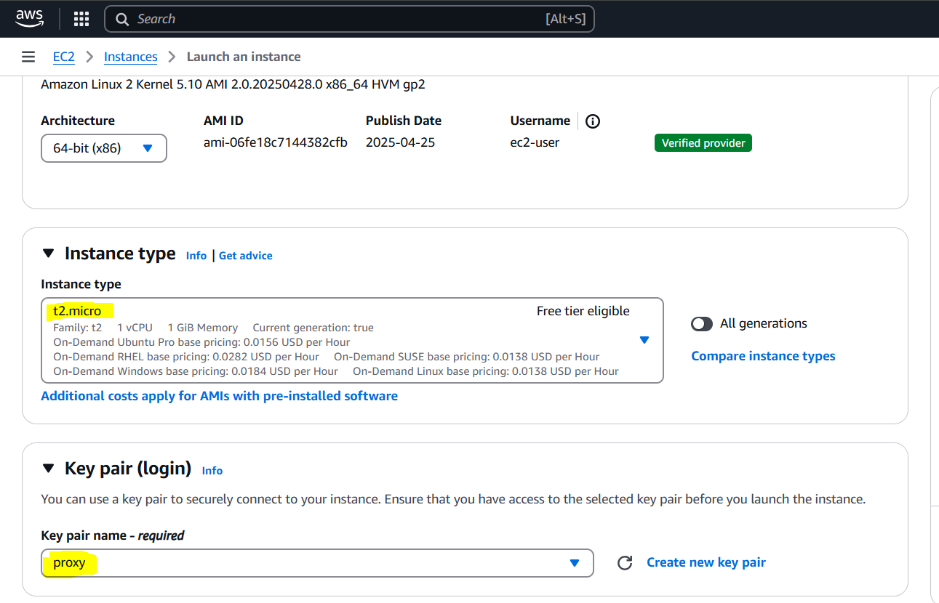

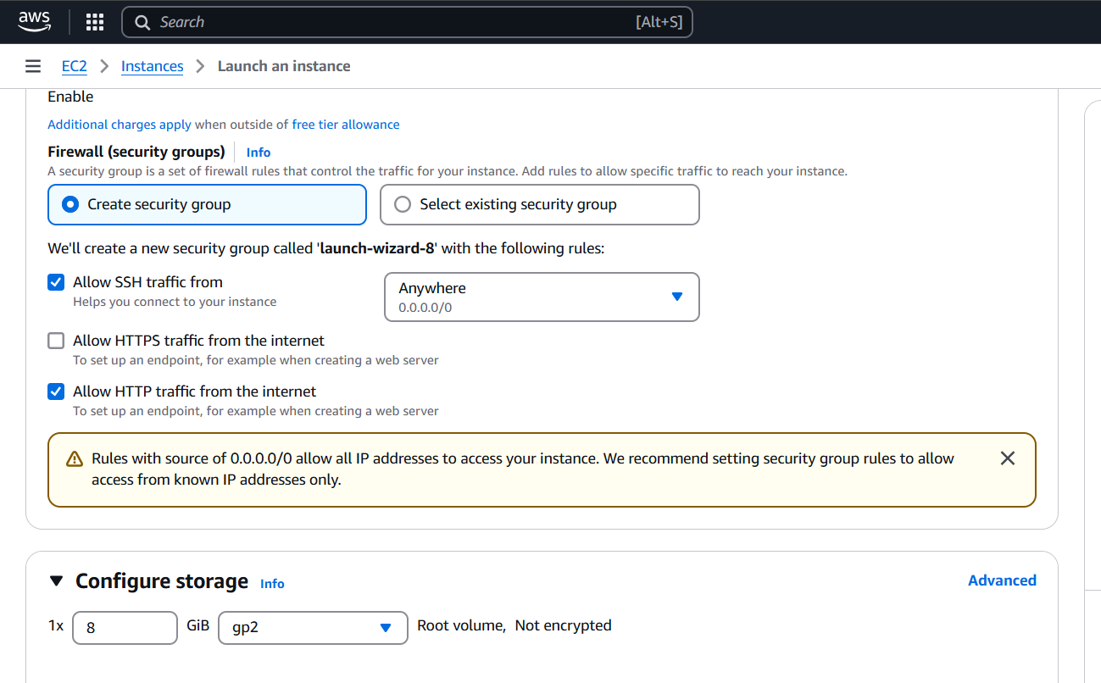 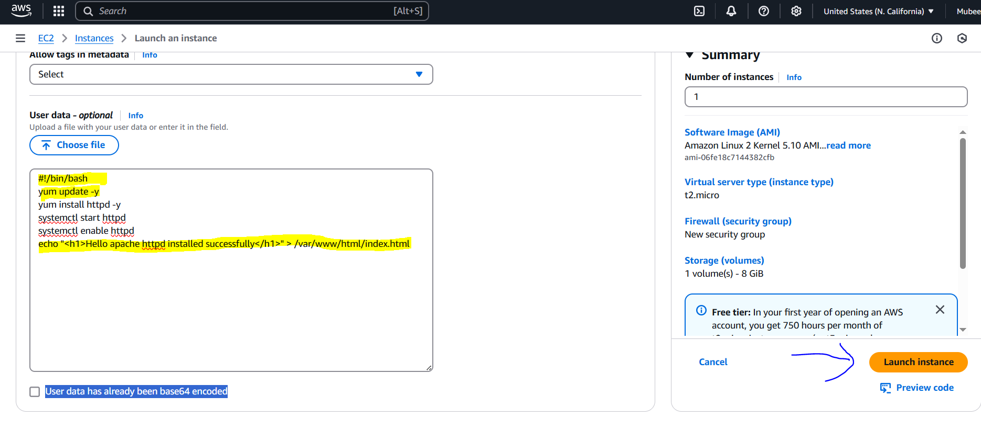

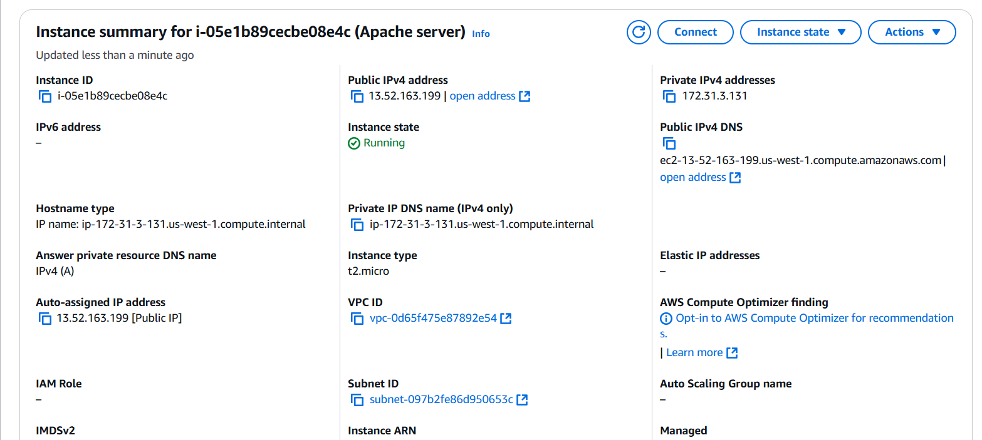

**Check in local browser.**

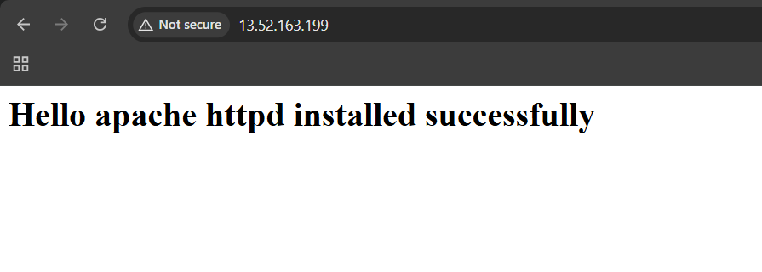

**2) Launch one ec2 using Ubuntu image and add script in user data to install Nginx.**

* **Log in to AWS Management Console**: Navigate to the [EC2 Dashboard](https://console.aws.amazon.com/ec2/).
* **Launch a New Instance**: Click on **Launch Instance**.
* **Choose Ubuntu Server AMI**: Select an Ubuntu Server AMI (e.g., Ubuntu Server 24.04 LTS).
* **Select Instance Type**: Choose **t2.micro** (eligible for the free tier).
* **Configure Instance Details**: In the **Configure Instance** section, scroll down to **Advanced Details**.
* **Add User Data Script**: In the **User data** field, paste the following script:

bash

CopyEdit

#!/bin/bash

apt update -y

apt install -y nginx

systemctl start nginx

systemctl enable nginx

echo "Hello nginx installed successfully" > /var/www/html/index.html

This script updates the system, installs Nginx, starts the service, enables it to start on boot, and creates a test HTML page.

* **Add Storage (Optional)**: Adjust storage settings if necessary.
* **Configure Security Group**: Create a new security group or select an existing one.
  + Ensure it allows inbound traffic on **port 22 (SSH)** and **port 80 (HTTP)**.
* **Review and Launch**: Review your settings and click **Launch**.
  + Select an existing key pair (proxy.pem) or create a new one to access the instance via SSH.

**✅ Verify Nginx Installation**

* **Obtain Public IP Address**: After the instance is running, note the **Public IPv4 address** from the EC2 Dashboard.
* **Access the Web Server**: Open a web browser and enter the instance's public IP address.

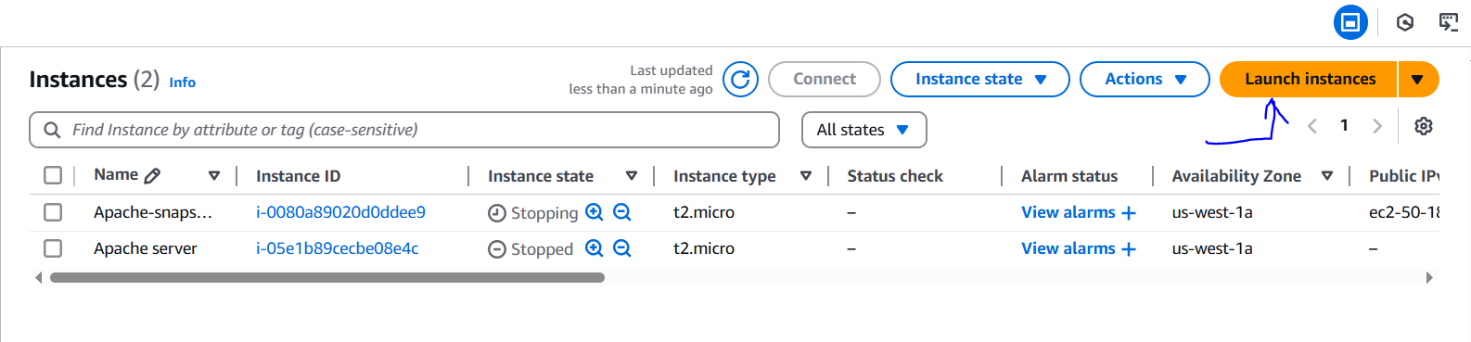

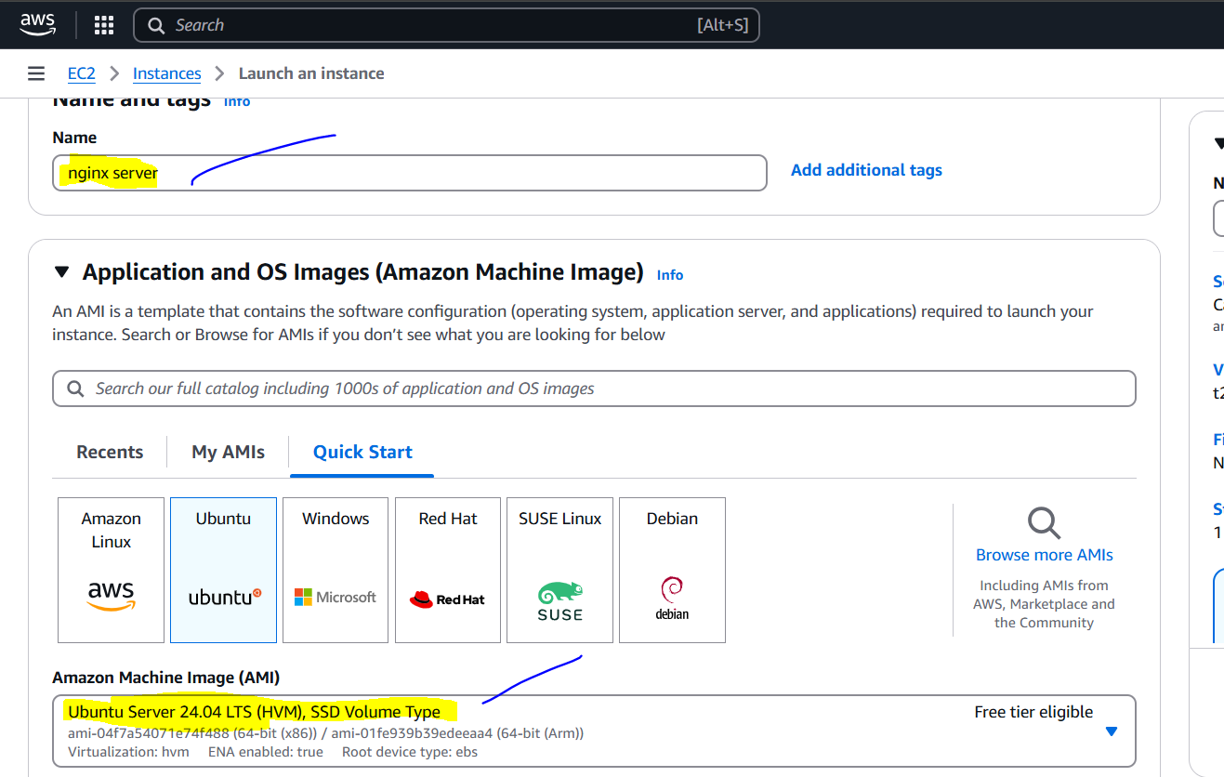

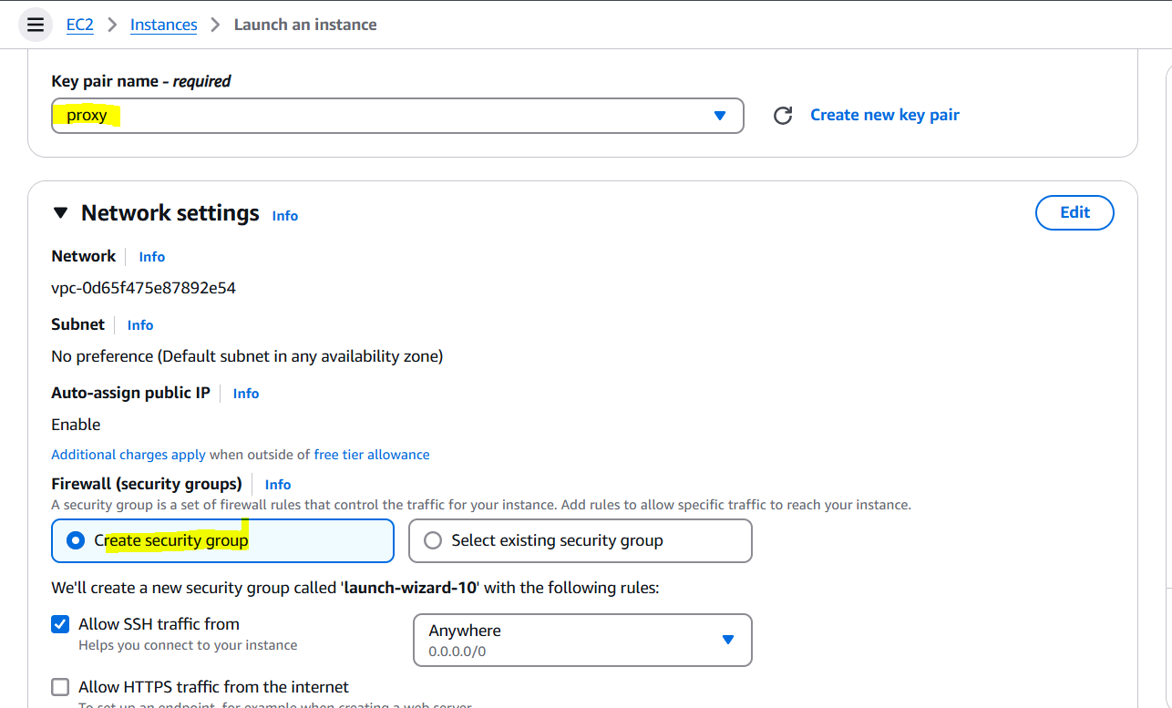

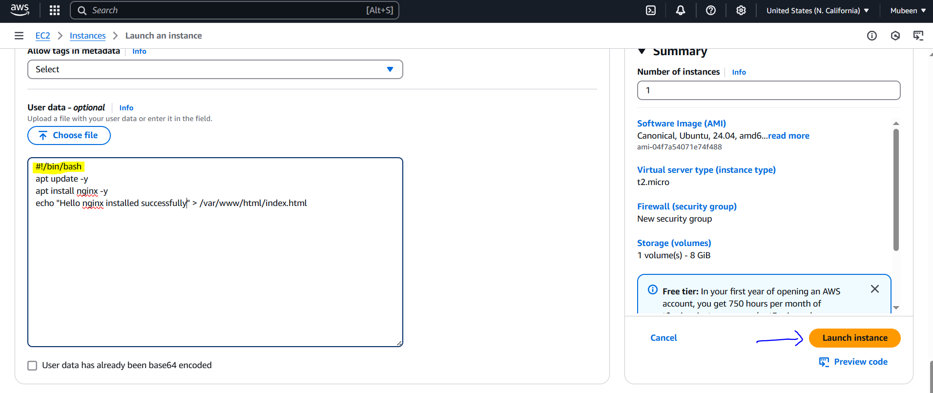

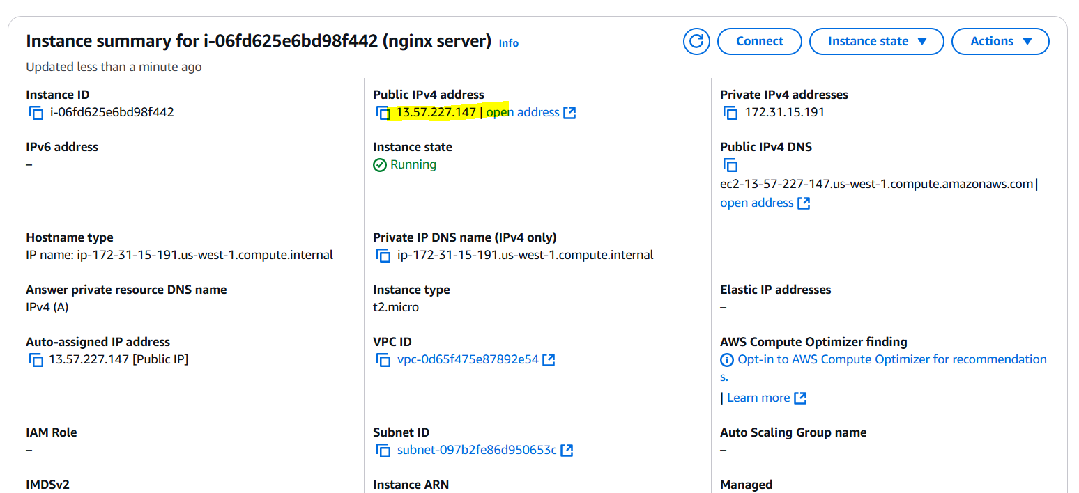

**Check from local browser with Public ip and port number.**

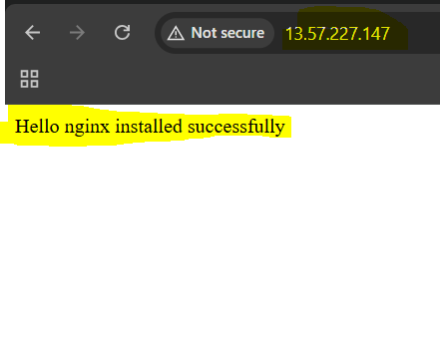

**3) Launch one windows server and install tomcat in windows.**

• **Launch EC2 Instance**: Navigate to the [EC2 Dashboard](https://console.aws.amazon.com/ec2/), click **Launch Instance**, and choose the **Microsoft Windows Server 2025 Base** AMI.

• **Instance Configuration**: Select **t3.medium** as the instance type to meet Windows memory requirements.

• **Key Pair**: Choose the existing key pair proxy.pem for SSH access.

• **Security Group**: Create a new security group allowing inbound traffic on **RDP (port 3389)** and **HTTP (port 80)**.

• **Instance Launch**: Review and launch the instance.[rds-tools.com](https://rds-tools.com/how-to-enable-remote-desktop-on-windows-server-setup/?utm_source=chatgpt.com)

• **Obtain Administrator Password**: After the instance is running, select it from the EC2 Dashboard, click **Connect**, and use the **Get Password** option with your proxy.pem key to retrieve the Windows Administrator password.

• **Connect via RDP**: Use an RDP client to connect to the instance using the public IP address, username Administrator, and the retrieved password.

• **Download Java**: In the Windows Server browser, download the latest Java JDK from the official [Oracle website](https://www.oracle.com/java/technologies/javase-jdk11-downloads.html).

• **Install Java**: Run the downloaded installer and follow the prompts to install Java.

• **Download Tomcat**: Download the latest Apache Tomcat zip file from the official [Tomcat website](https://tomcat.apache.org/download-90.cgi).

• **Extract Tomcat**: Extract the downloaded zip file to a directory of your choice, e.g., C:\Tomcat.

• **Start Tomcat**: Navigate to the bin folder within the Tomcat directory and double-click startup.bat to start the Tomcat server.

• **Verify Installation**: Open a web browser and enter http://<Public-IP>:8080. You should see the Tomcat welcome page, confirming that Tomcat is running.

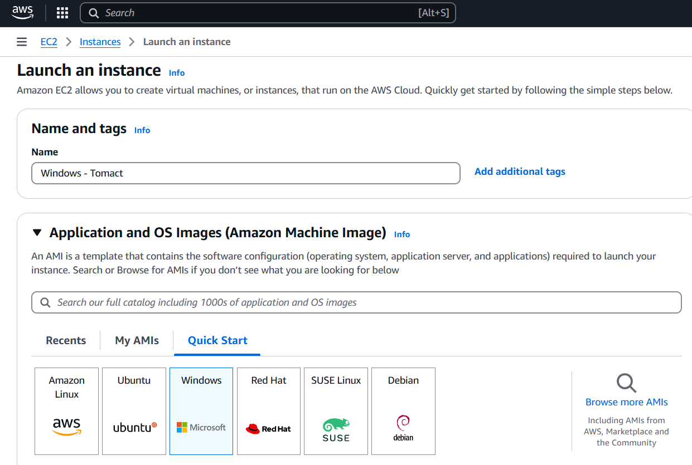

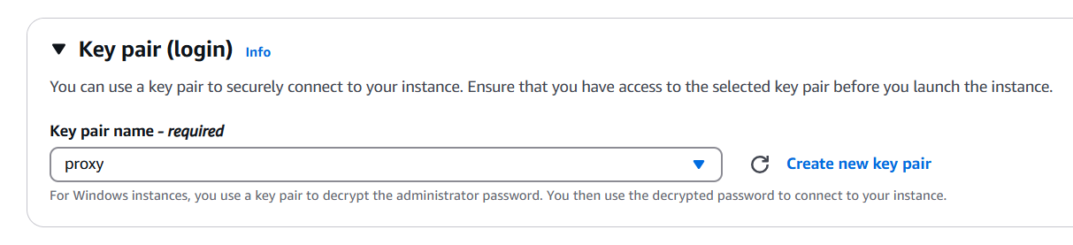

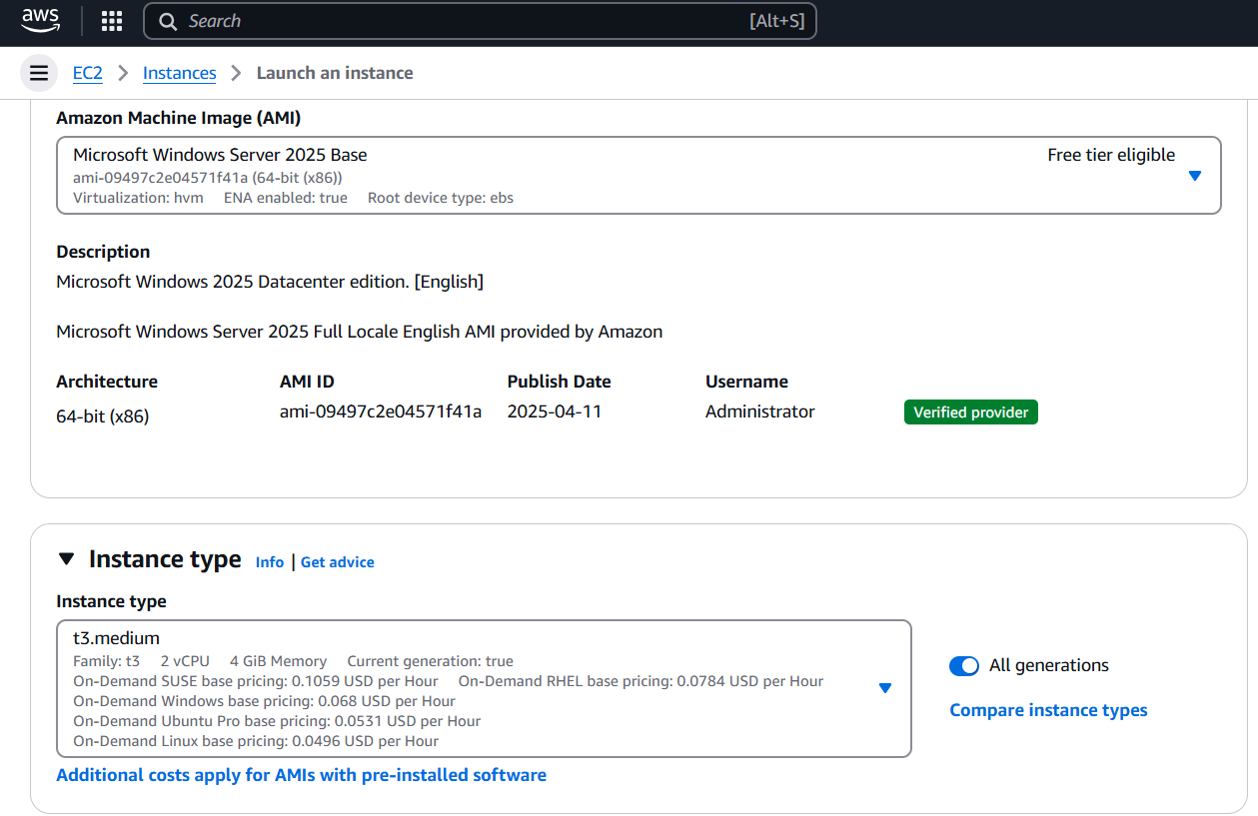

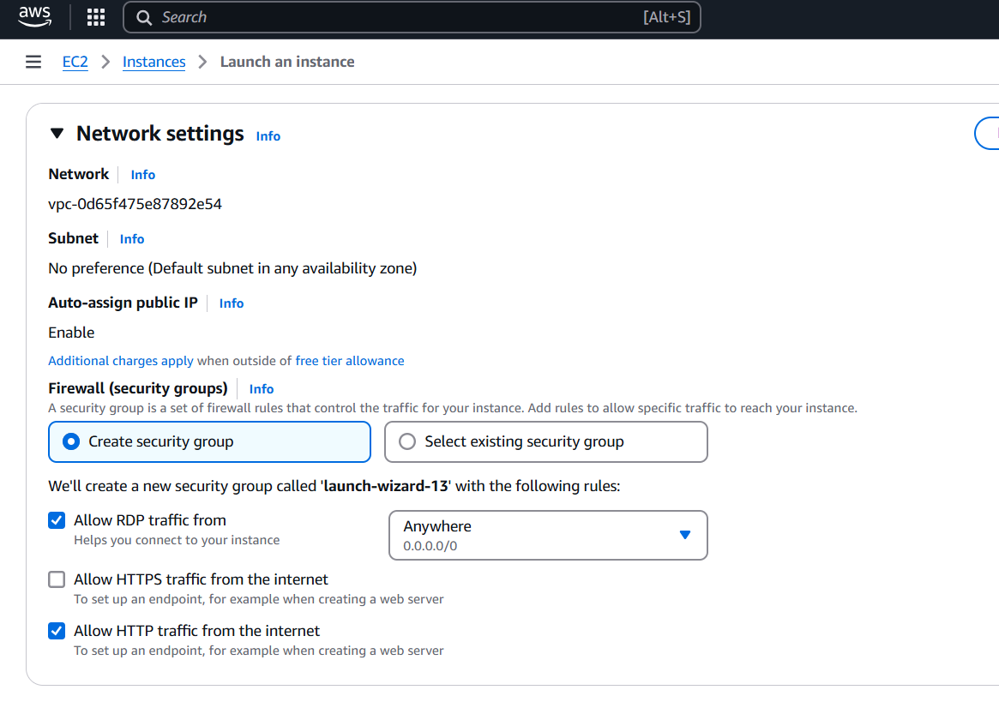

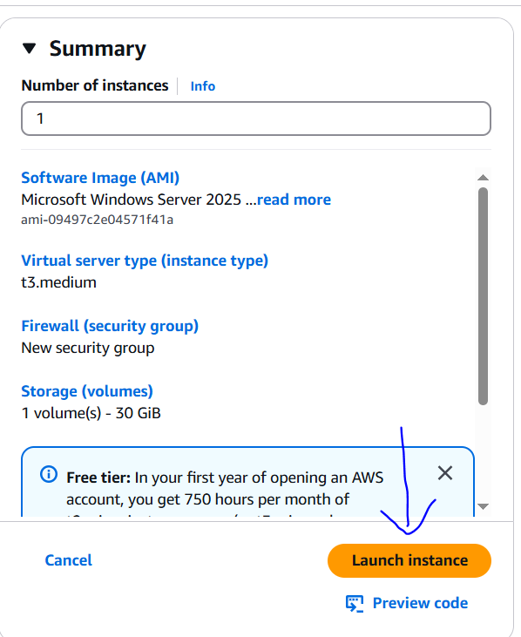

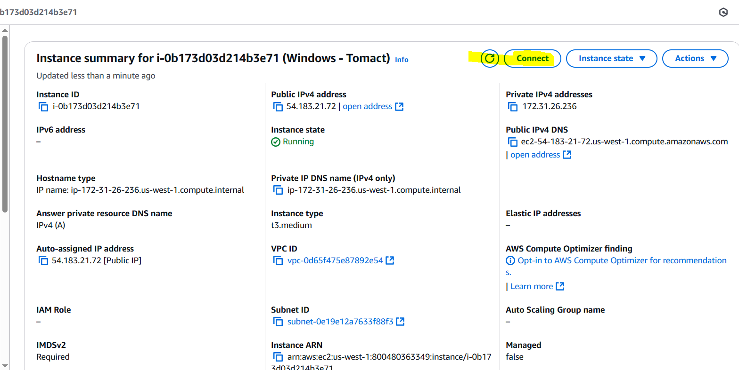

**Click on get password**

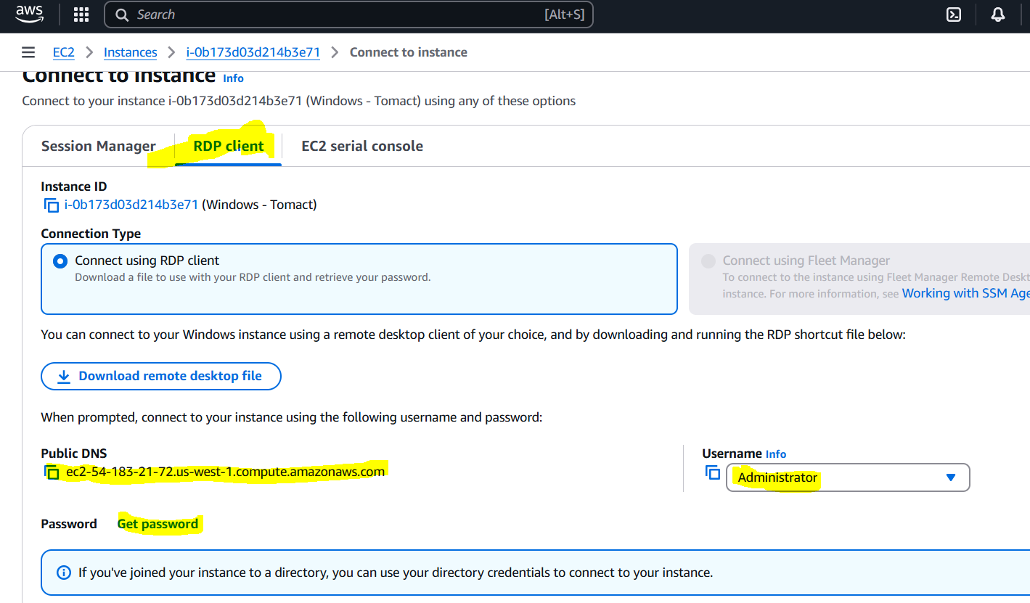

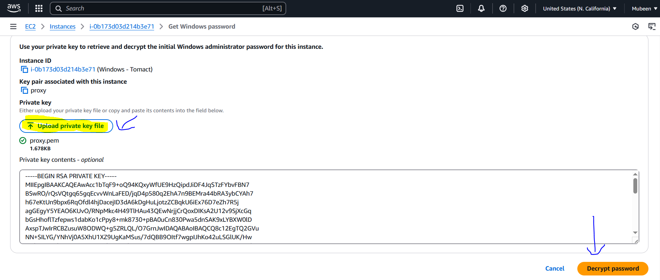 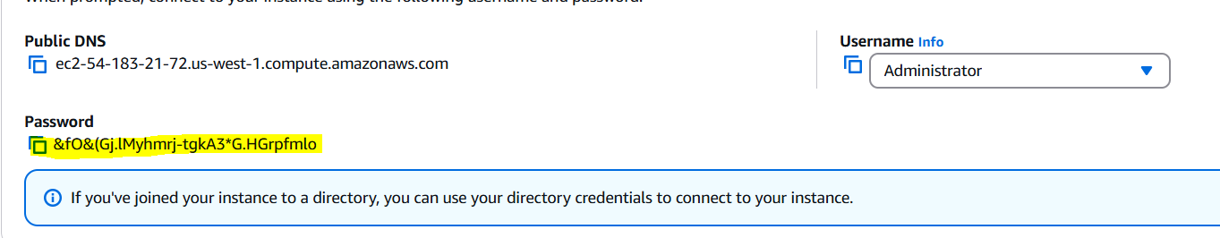

**In RDC, Public ip and username as admin then click on connect**

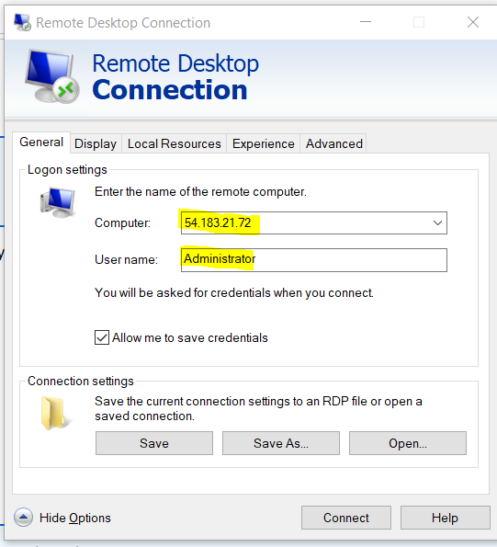

**Enter password then connect**

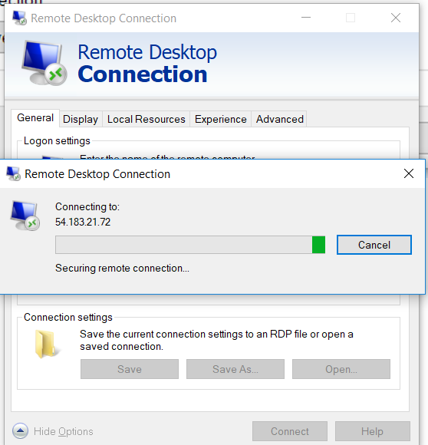

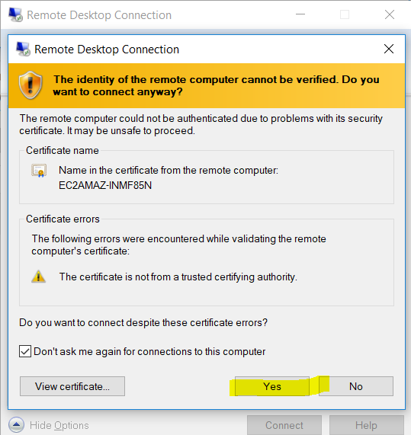

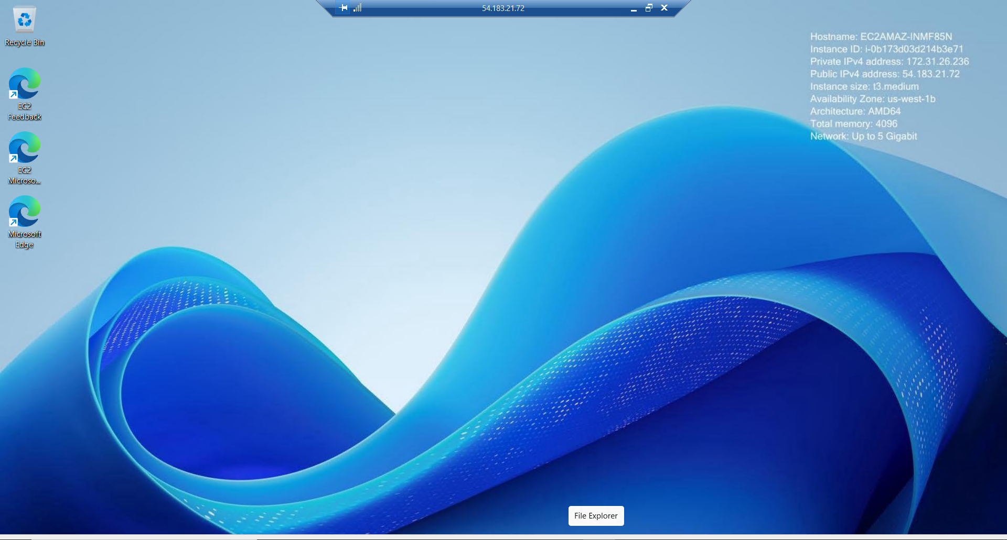

**Msi for easy config (gpt)**

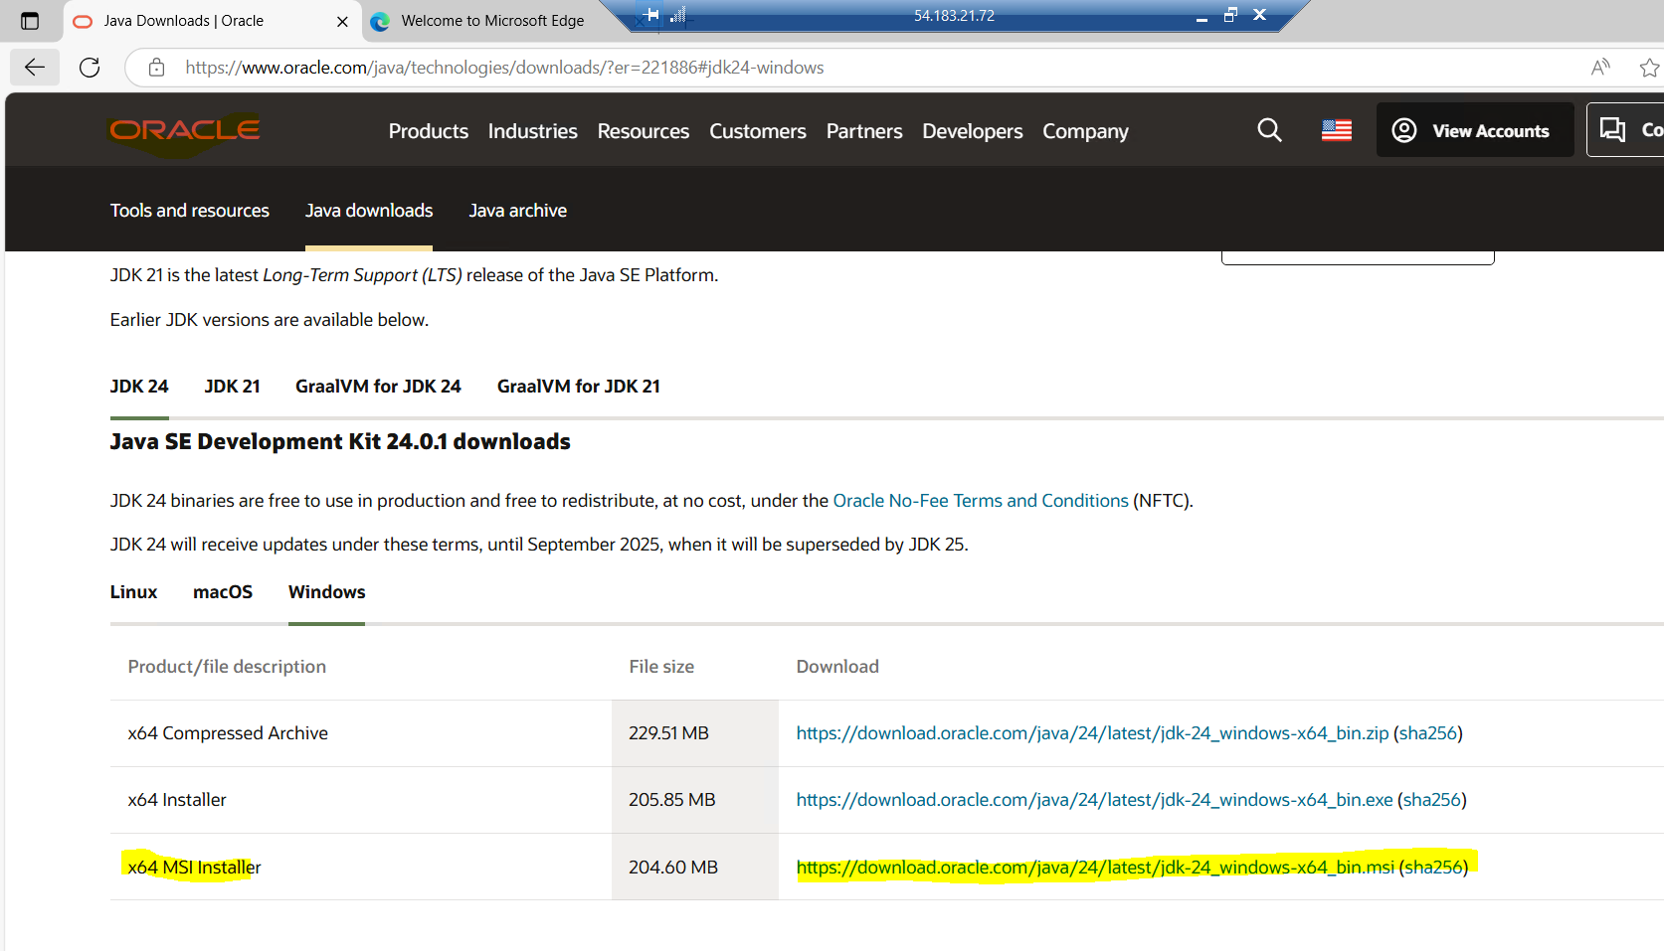

**java -version**

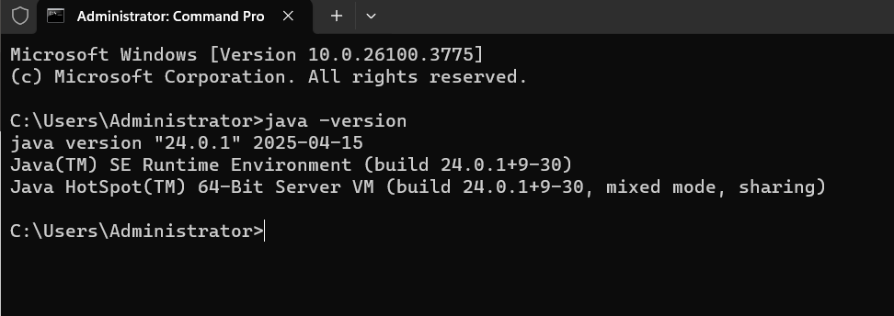

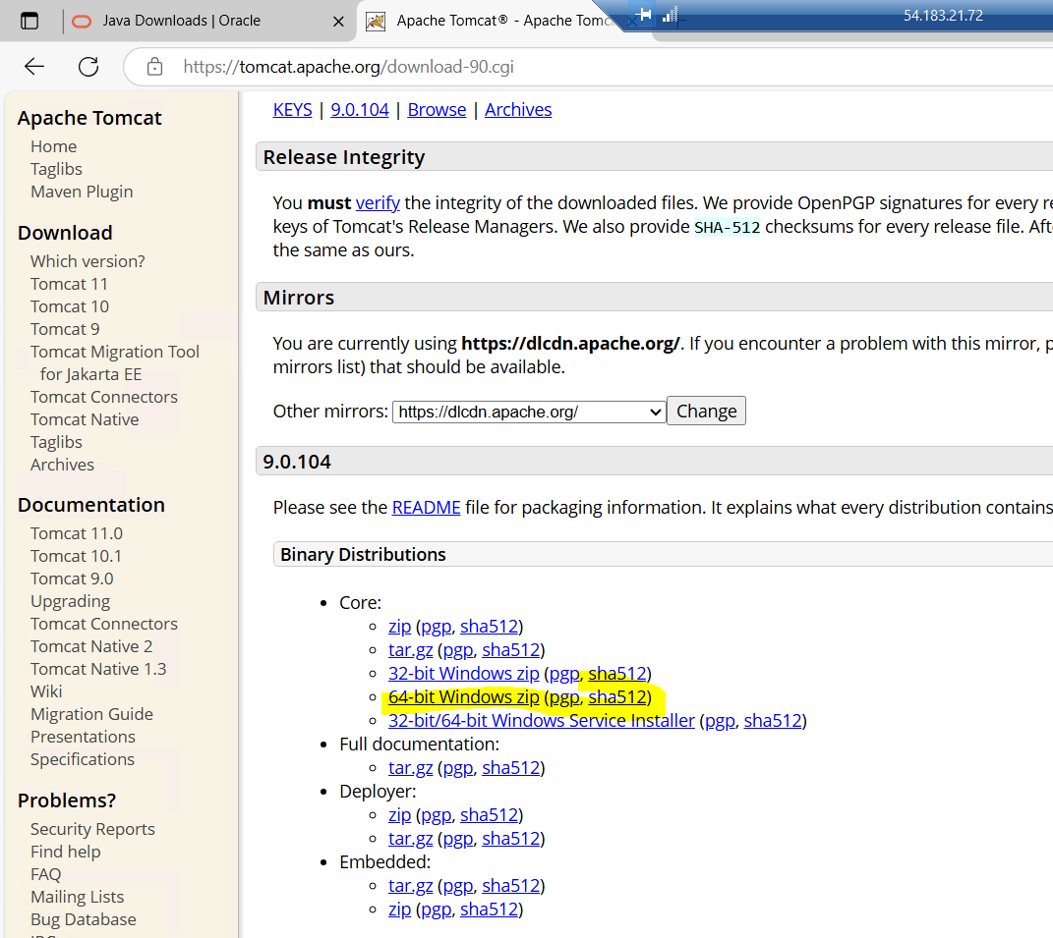

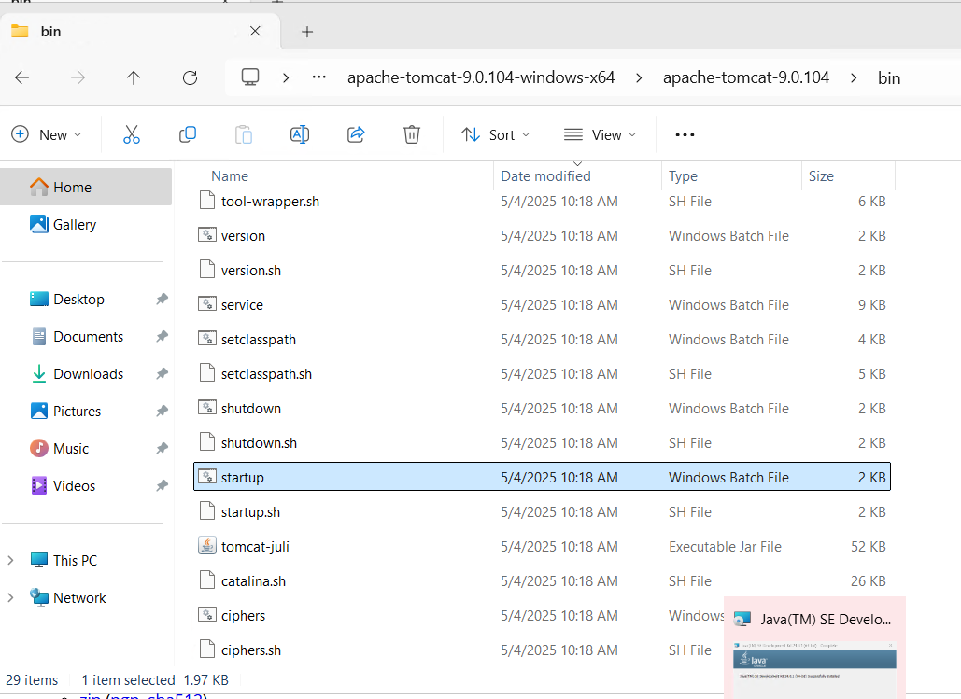

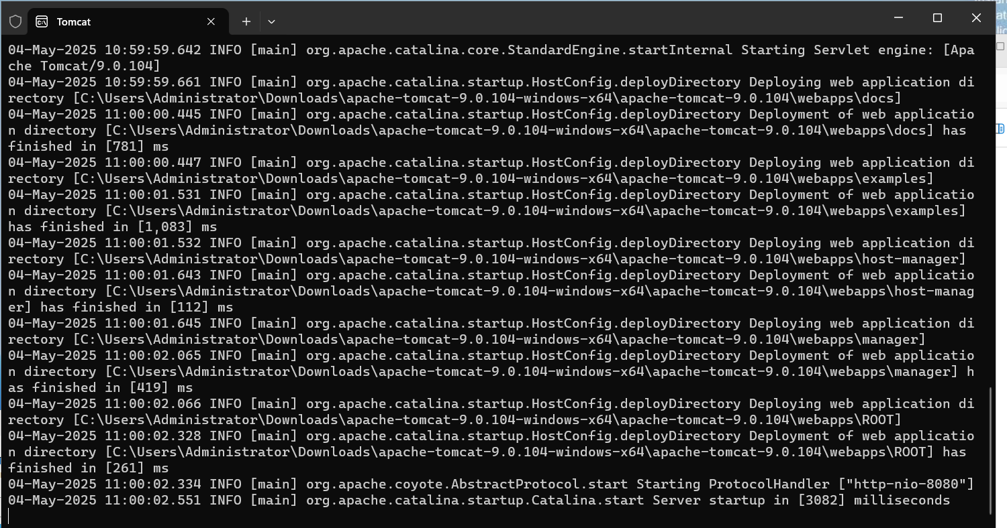

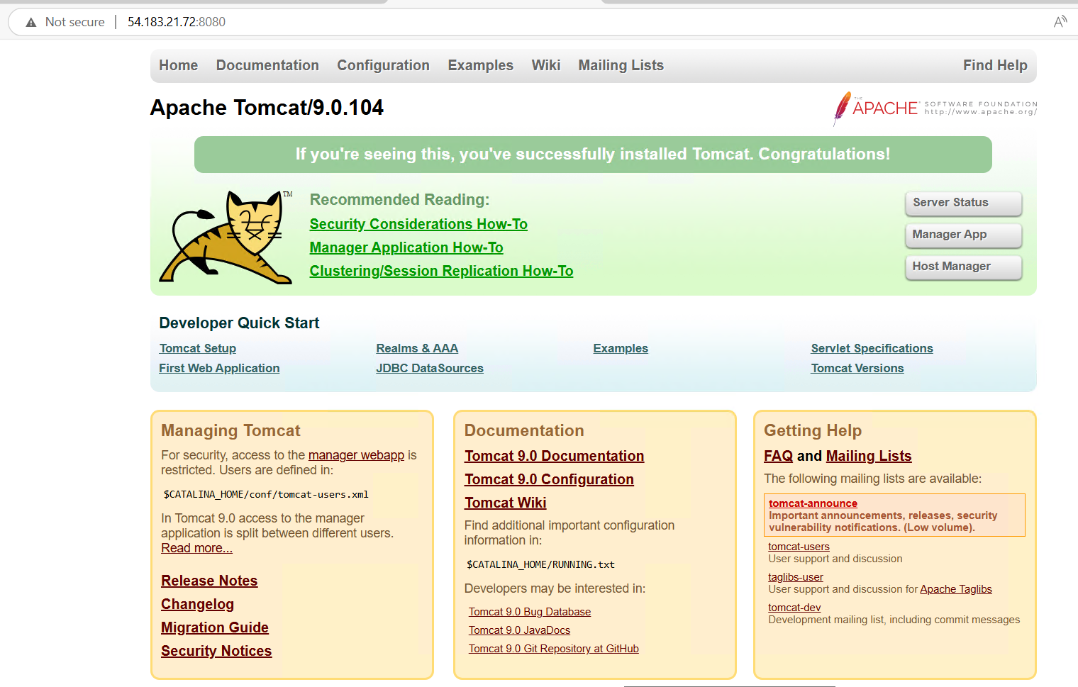

**4) Take snapshot of the instance created in Task 1.**

**🖥️ Create AMI from Existing EC2 Instance (Apache HTTPD Installed)**

* **Select EC2 Instance**: In the [EC2 Dashboard](https://console.aws.amazon.com/ec2/), navigate to **Instances**, and select the instance where Apache HTTP Server is installed.
* **Create Image**: Click on **Actions** > **Image and templates** > **Create image**.
* **Configure Image**:
  + **Image name**: apache-snapshot
  + **Description**: httpd installed
  + **Reboot instance**: Checked (recommended to ensure a clean image)

**Launch New EC2 Instance from Created AMI**

* **Navigate to AMIs**: In the EC2 Dashboard, under **Images**, select **AMIs**.[Amazon Web Services Repost](https://repost.aws/knowledge-center/launch-instance-custom-ami?utm_source=chatgpt.com)
* **Select Custom AMI**: Find and select the apache-snapshot AMI you just created.
* **Launch Instance**: Click on **Launch instance from image**.[AWS Documentation+1Amazon Web Services Repost+1](https://docs.aws.amazon.com/AWSEC2/latest/UserGuide/LaunchingAndUsingInstances.html?utm_source=chatgpt.com)
* **Configure Instance**:
  + **Instance name**: windows-tomcat
  + **Security Group**: Assign the appropriate security group that allows inbound traffic on HTTP (port 80) and any other necessary ports.
* **Launch Instance**: Review your settings and click **Launch** to start the new instance.

### ✅ Verify Apache HTTP Server on New Instance

* **Obtain Public IP**: Once the new instance is running, note its **Public IPv4 address** from the EC2 Dashboard.
* **Access via Browser**: Open a web browser and enter the public IP address of the new instance.
  + Example: http://<Public-IP>
* **Verify Apache Page**: You should see the Apache HTTP Server default page, confirming that Apache is running correctly on the new instance.

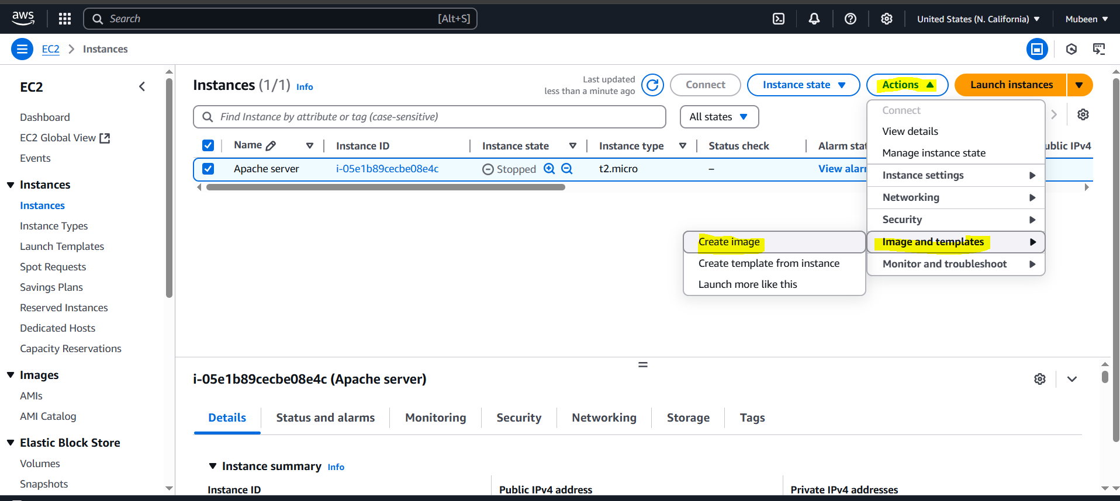

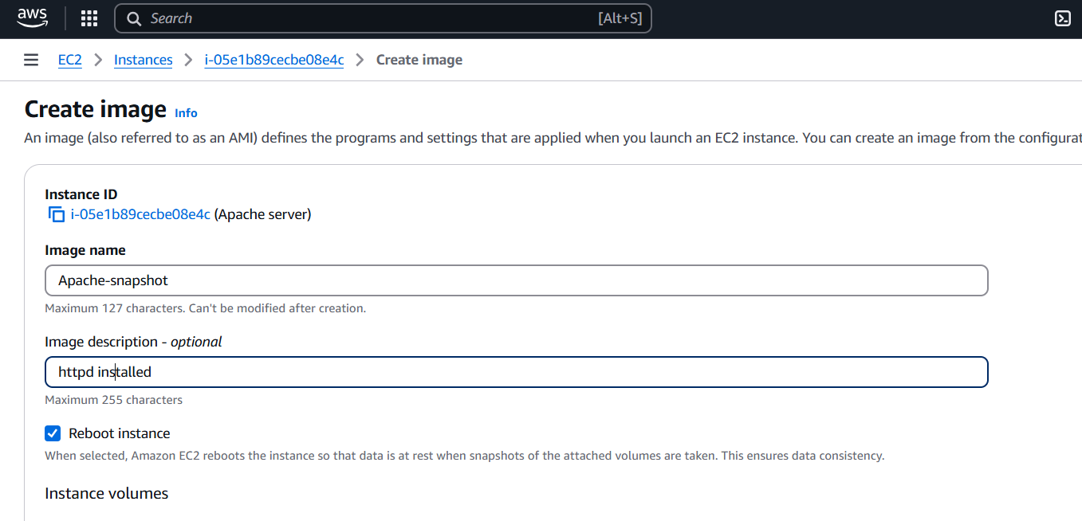

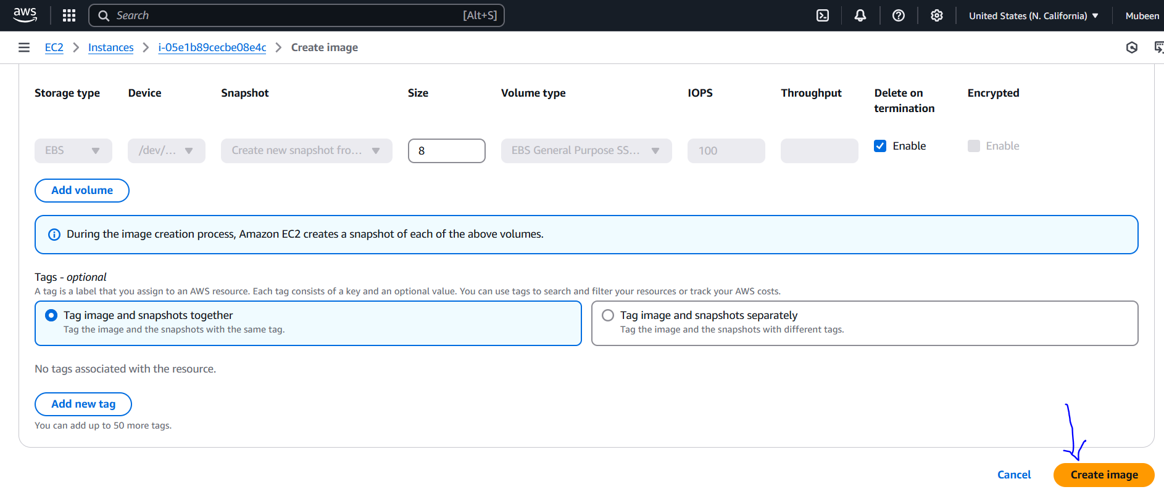

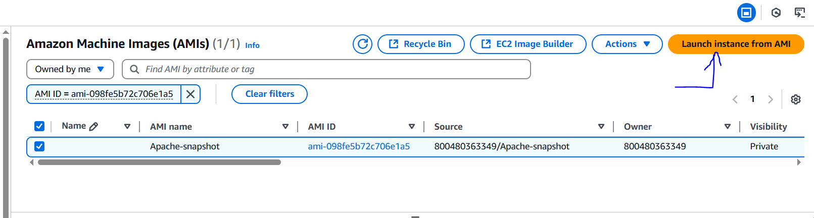

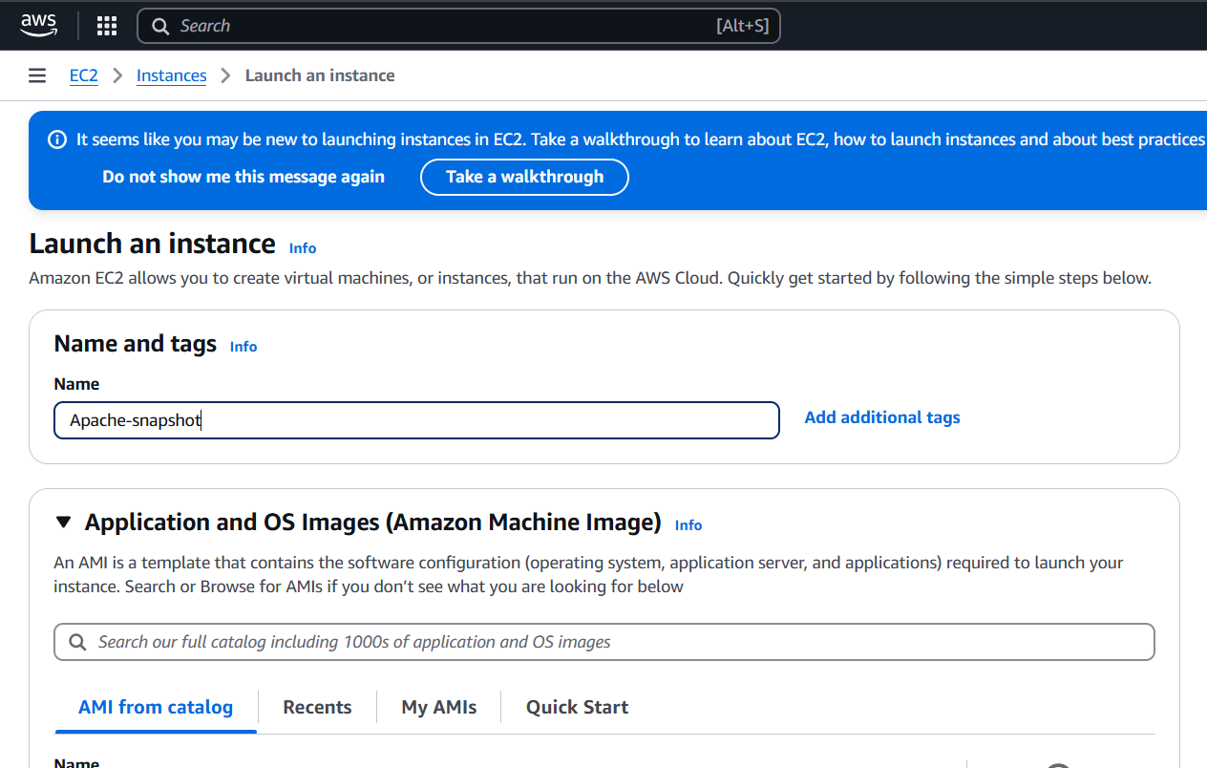

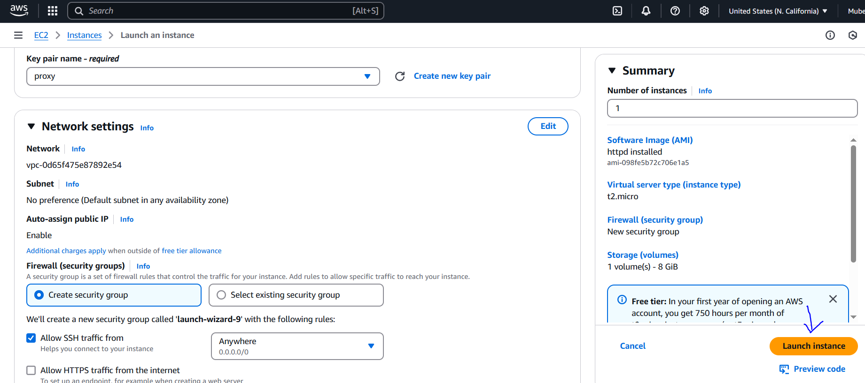

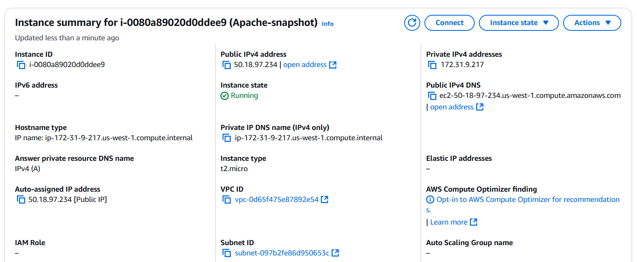

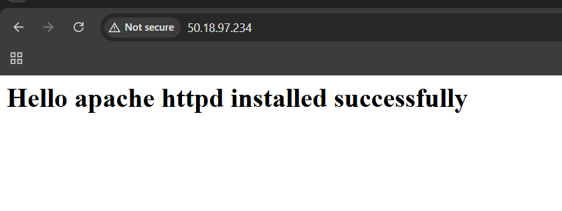

**5) Assign password less authentication for ec2 created on Task 2.**

**Step 1**: Generate SSH key (if you didn't have one)

Run ssh-keygen on your local machine (this will generate a new key pair if you don't have one).

**Step 2**: Copy public key

I already have a public key, so you ran **cat ~/.ssh/id_rsa.pub** and copied the output.

**Step 3**: Add public key to EC2 instance

I pasted the copied public key into **~/.ssh/authorized_keys** on the EC2 instance (Ubuntu server).

Important: Set permissions

Make sure the permissions are correct:

bash

**chmod 700 ~/.ssh**

**chmod 600 ~/.ssh/authorized_keys**

**Step 4**: Connect using SSH

Now, you can connect to the EC2 instance without a password using:

bash

**ssh ubuntu@Pub ip**

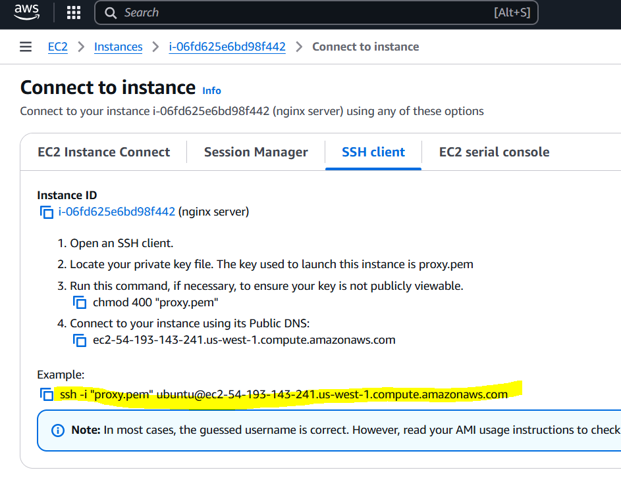

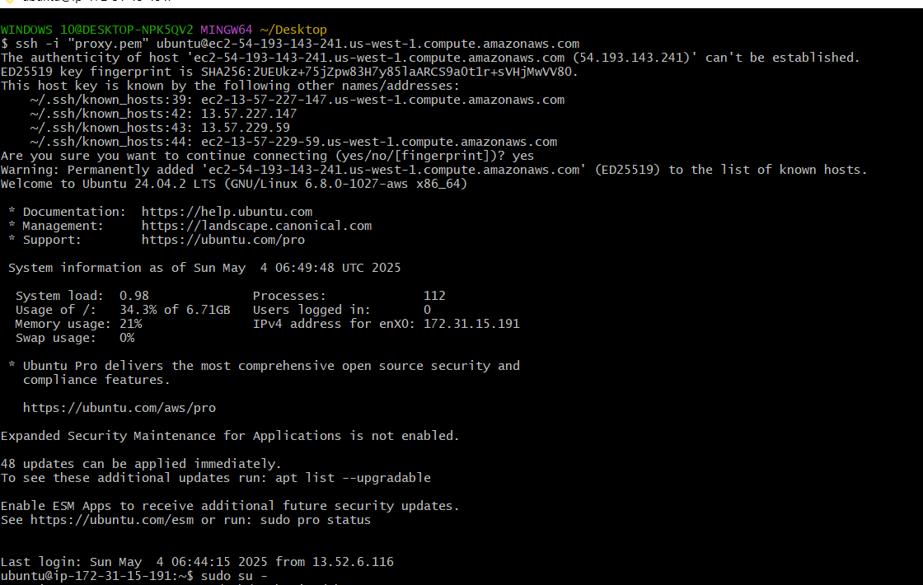



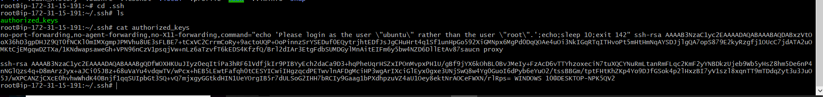

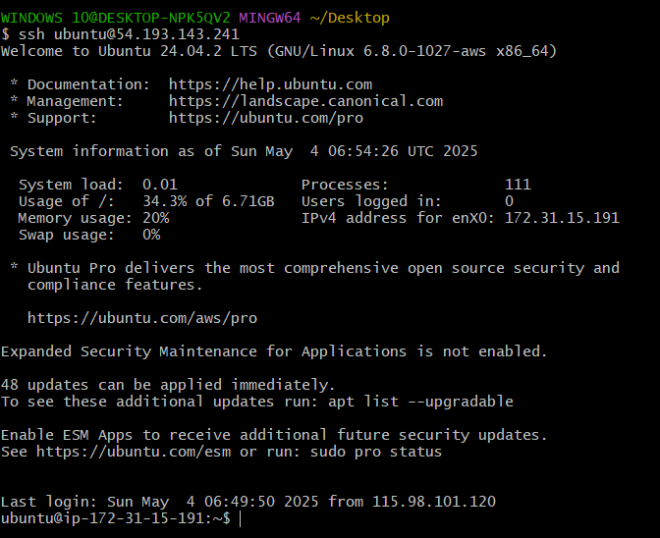

**6) Launch any ec2 using spot purchasing option.**

1. Go to the AWS Management Console and navigate to the EC2 dashboard.

2. Click **"Launch Instance"** and select the required infrastructure (AMI, instance type, etc.).

3. In the **"Advanced details"** section, click on **"Spot instances".**

4. Select "**Request Spot instances"** and set **"Maximum price"** to **"No maximum price".**

5. Launch the instance.

**Verification:**

1. Go to the **EC2 dashboard** and check if the instance is created.

2. Confirm the instance type by checking the **"Lifecycle"** column, which should display **"spot".**

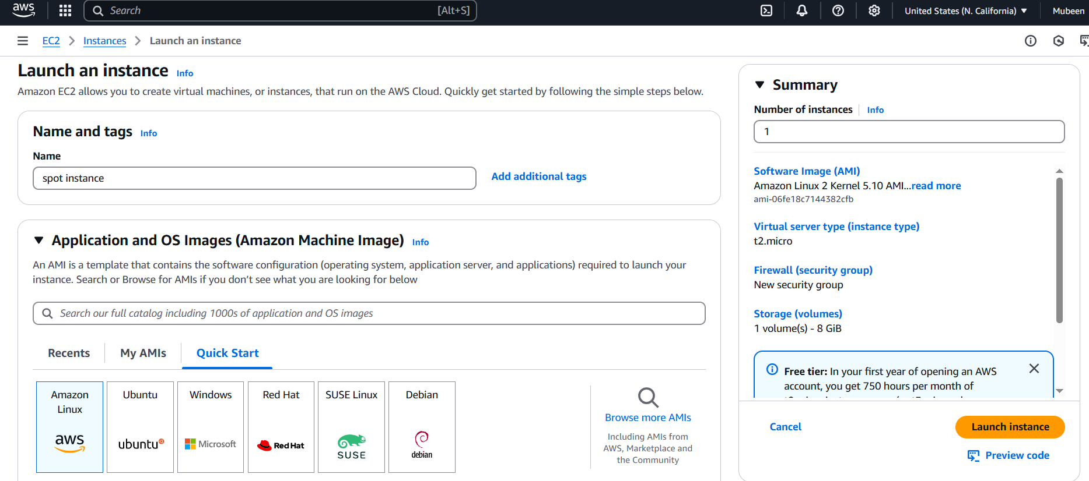

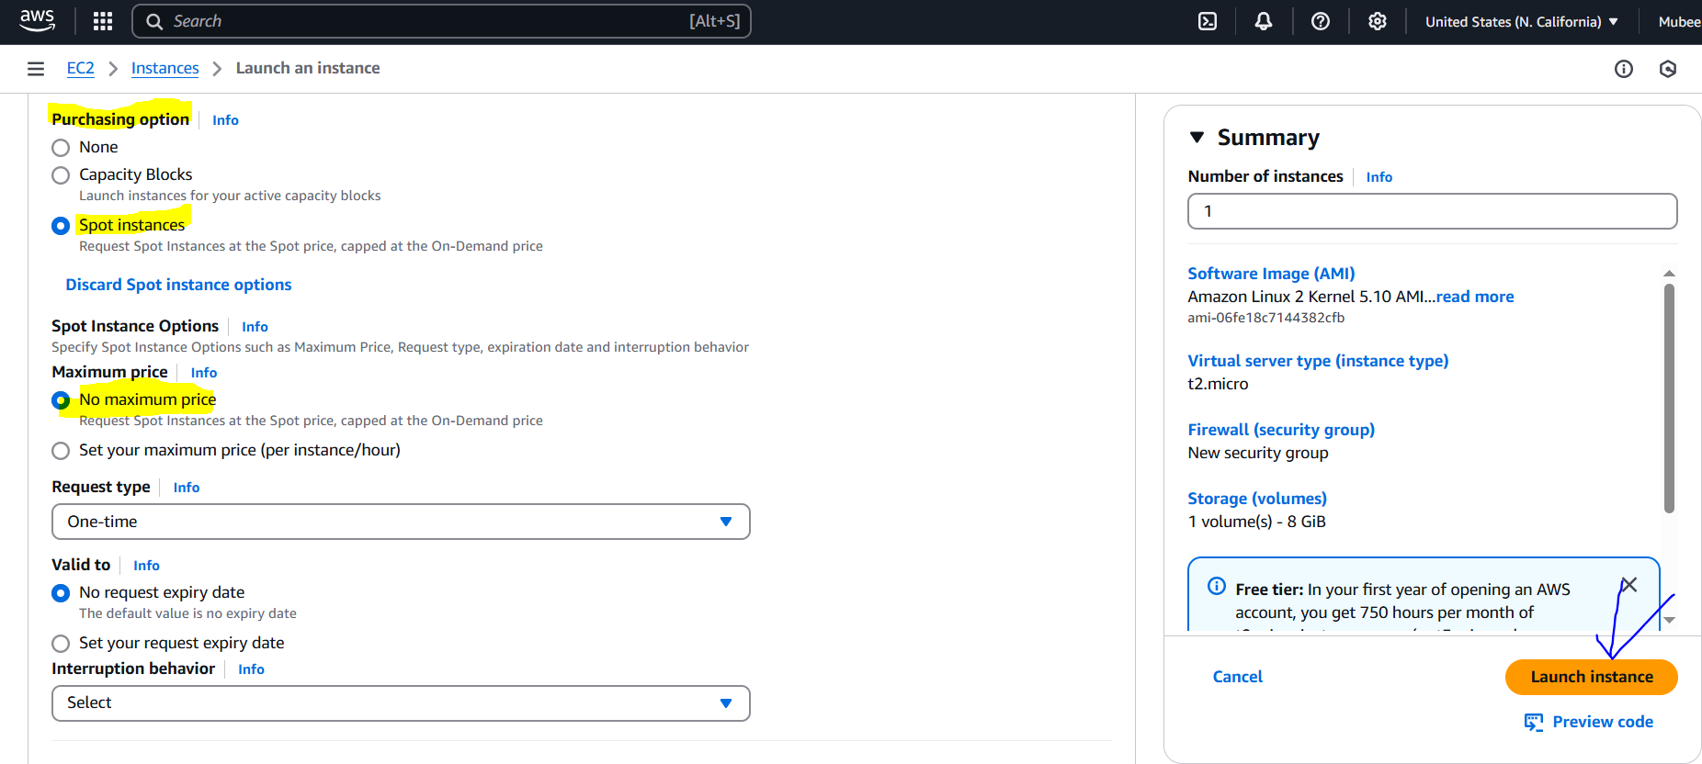

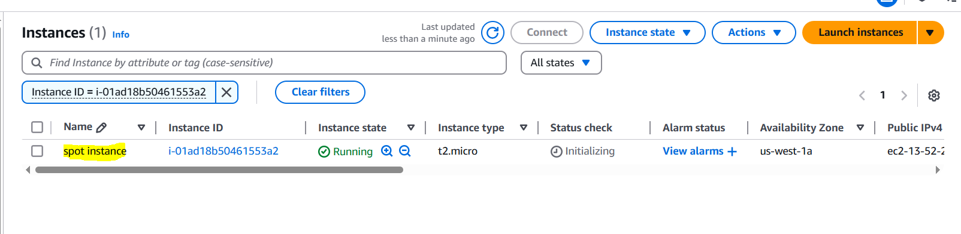

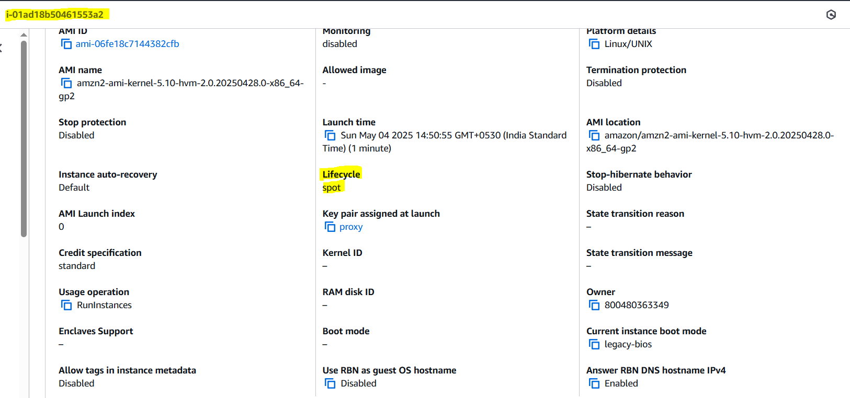

**7) Enable Termination policy on ec2 created in Task 2.**

**Enabling Termination Protection:**

1. Go to the AWS Management Console and navigate to the EC2 dashboard.

2. Select the instance (Ubuntu server with Nginx) you want to protect.

3. Click **"Actions"** and then select **"Instance settings".**

4. Click **"Change termination protection".**

5. In the pop-up window, check the box next to **"Enable"** to activate termination protection.

6. Click **"Save"** to apply the changes.

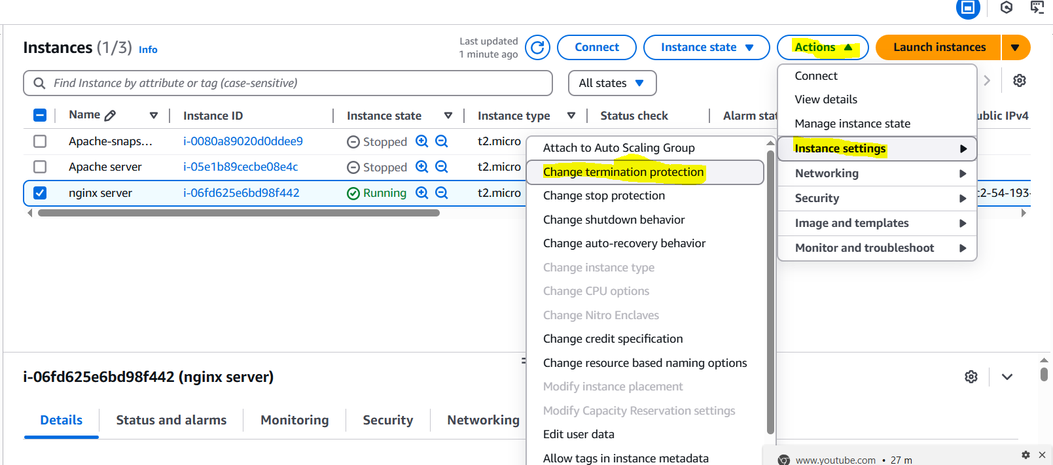

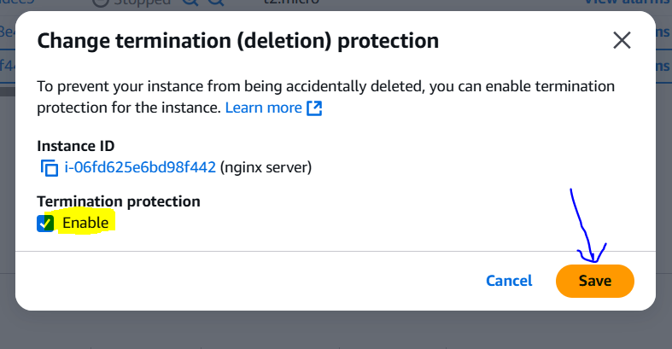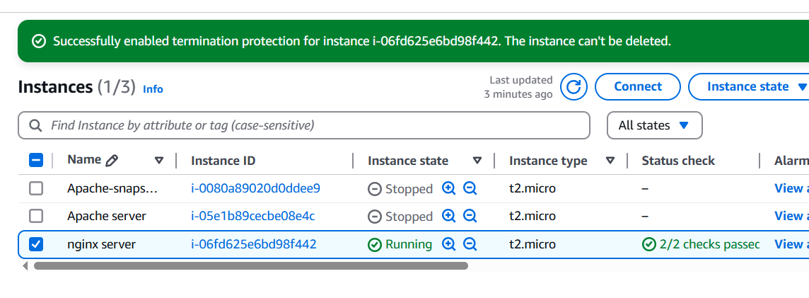

**8) Launch one ec2 using Aws CLI.**

**1. Prerequisites:**

- Install AWS CLI and Python.

- Create **access key** and **secret key** from AWS Console (**Security Credentials**).

**2. Configure AWS CLI:**

- Run aws configure and enter:

**- Access key**

**- Secret key**

**- Region (e.g., us-west-1)**

**- Output format (e.g., json)**

- Verify configuration using **aws configure list**

- Check AWS CLI version: **aws –version**

**3. Find required details:**

- Find latest Amazon Machine Image (AMI) ID:

**- aws ec2 describe-images --owners amazon --filters 'Name=name,Values=amzn2-ami-hvm-2.0.*-x86_64-gp2' --query 'Images | sort_by(@, &CreationDate) | [-1].ImageId' --output text**

**- List security groups:**

**- aws ec2 describe-security-groups –query 'SecurityGroups[*].{ID:GroupId,Name:GroupName}'**

- List subnets:

**- aws ec2 describe-subnets --query 'Subnets[*].{ID:SubnetId,AZ:AvailabilityZone}'**

**4. Launch EC2 instance:**

- Use aws ec2 run-instances command with required parameters:

**- aws ec2 run-instances**

**--image-id ami-08be293cd057c7a9d**

**--count 1 --instance-type t2.micro**

**--key-name proxy**

**--security-group-ids sg-08b0080dc59e01f4c**

**--subnet-id subnet-097b2fe86d950653c --tag-specifications** **'ResourceType=instance,Tags=[{Key=Name,Value=Aws cli}]' --region us-west-1**

**5. Verify:**

- Check the output of the run-instances command.

- Connect to the instance using SSH: ssh -i mykey.pem ec2-user@pub-ip

- Verify the new instance in the AWS Console.

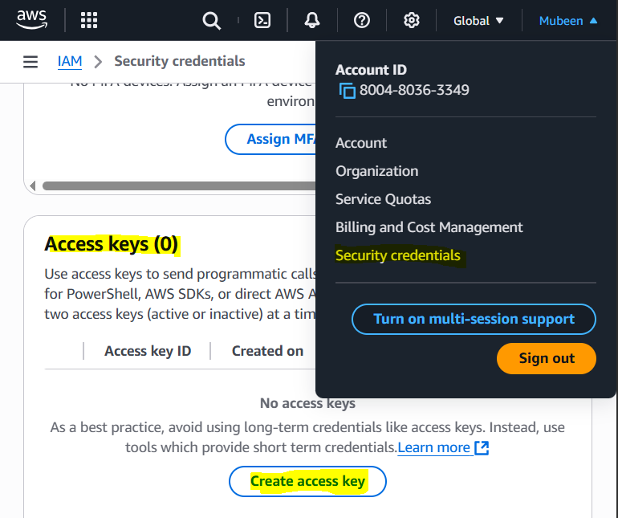

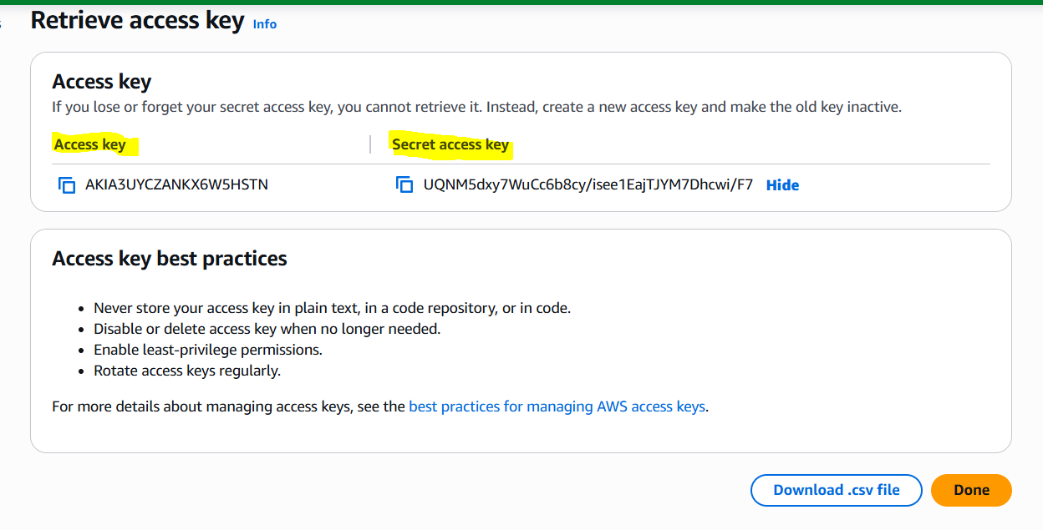

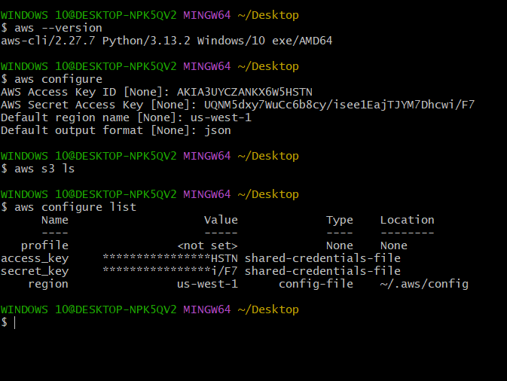

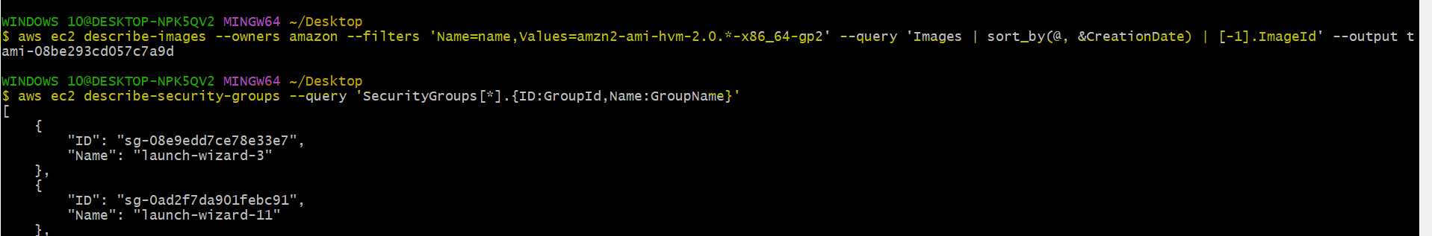

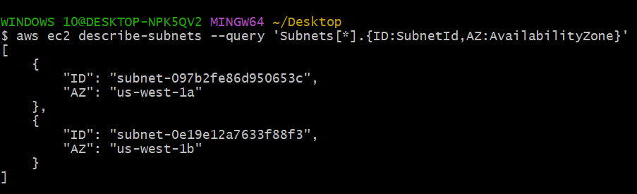

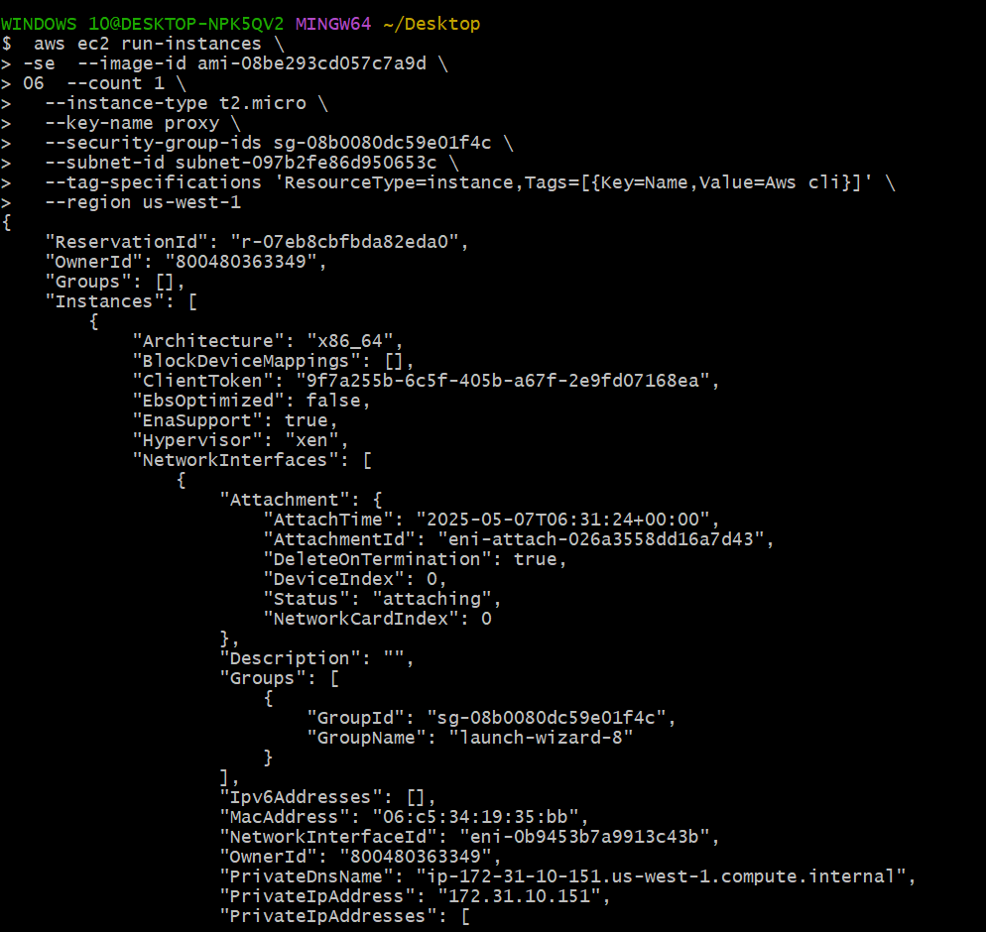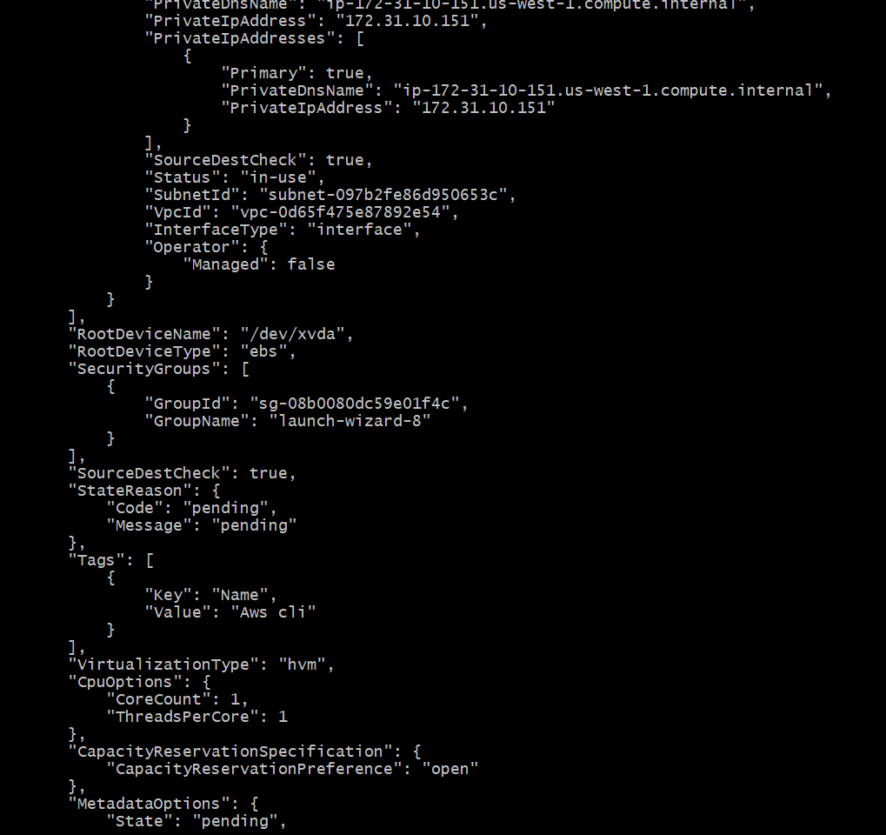

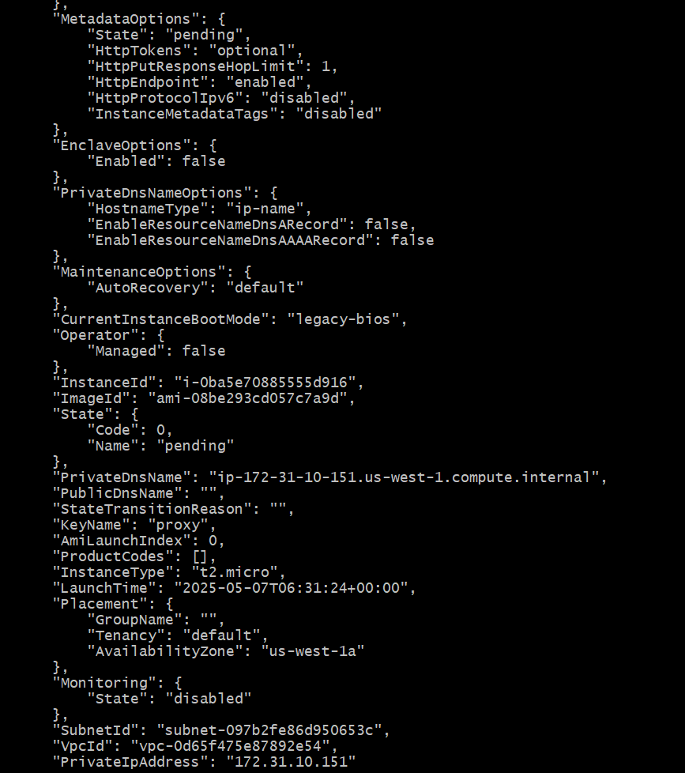

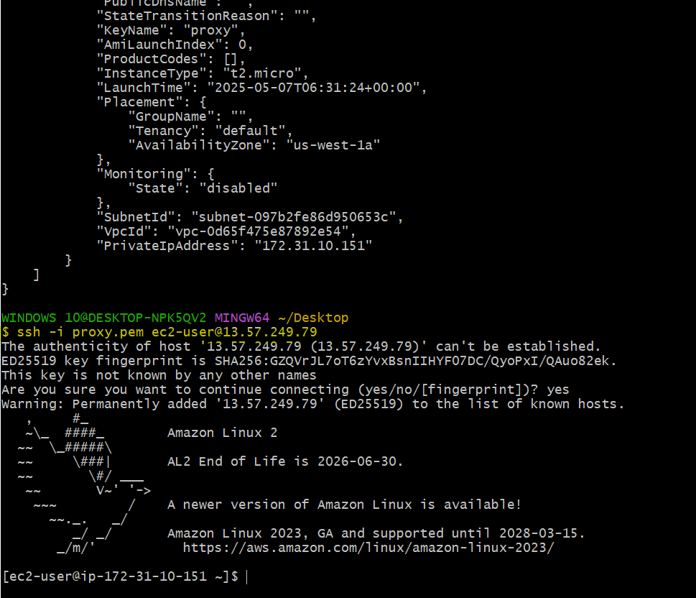

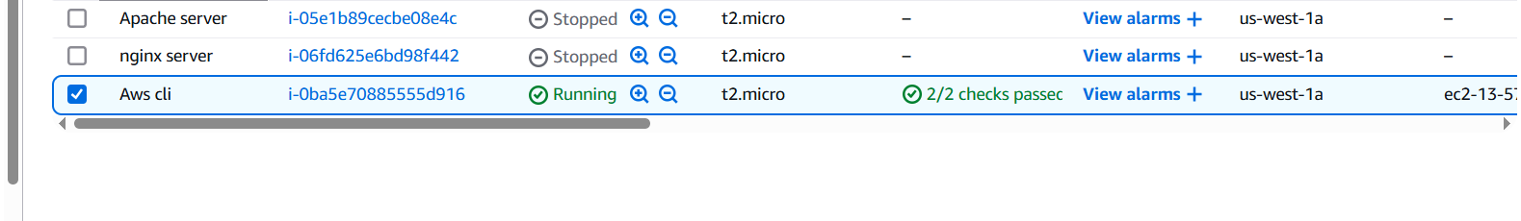

**THE - END**